Day 28: 22-11-2025:

Your need to publish your image individually or using docker-compose
Locally provide all service details in compose file
Build your project using mvc package and create Dockerfile

services:
product-service:
build: ./ProductRestAPIUsingSpringData/
image: akashkale/spring-boot-with-docker:upgrade-1.2
ports:
- 80:8080
depends_on:
- mysql-service
restart: always
mysql-service:
image: mysql:8.0
ports:
- 3307:3306
environment:
- MYSQL_ROOT_PASSWORD=root
- MYSQL_DATABASE=upgrad_db
restart: always

then you need to push one or more images to docker hub using
docker-compose build
then
docker-compose push

Launch the EC2 instance
Open the ports number of all services as well as database.
Install Docker and download the Docker compose file

sudo yum install docker
sudo service docker start

Download the current stable release of Docker Compose

sudo curl -L https://github.com/docker/compose/releases/latest/download/docker-compose-$(uname -s)-$(uname -m) -o /usr/local/bin/docker-compose

Give the permission

sudo chmod +x /usr/local/bin/docker-compose

docker-compose version

using
nano docker-compose.yml it open nano terminal

services:
product-service:
image: akashkale/spring-boot-with-docker:upgrade-1.2
ports:
- 80:8080
depends_on:
- mysql-service
restart: always
mysql-service:
image: mysql:8.0
ports:
- 3307:3306
environment:
- MYSQL_ROOT_PASSWORD=root
- MYSQL_DATABASE=upgrad_db
restart: always
sudo docker-compose up
or
sudo docker-compose up -d

to open mysql container os in ec2 instance
sudo docker exec -it dockercontainerid bash

to connect db

mysql -u root -p
- Root
Then check database and tables.

Using public ip address you can access your end point

RDS : Relational database system : AWS provided RDS service which provide all RDBMS databases.

Spring AOP: Aspect Oriented Programming

Procedure language like C
Object oriented language like C++ or Java
Aspect Oriented language like Spring framework one module ie Spring AOP

In procedure language generally we focus only functionality or coding. But In object oriented language we focus only property rather than functionality.
In AOP we need to focus on functionality. According to AOP the functionality mainly divided into 2 parts.
- Core concern : core or actual functionality
Withdraw, deposit etc.
- Cross cutting concern : these are functionality which support to achieve to core functionality.
Login, security, db details.
AOP mainly focus on cross cutting concern or functionality.

Join point :Joint point is a point of your application such as method execution, exception handling, field access.
Advice : Advice represents an action in your application such as method execution, exception handling access etc.
Using join point we can do different types of advice.

5 types of advice
- Before Advice. : it execute before method execution
- After advice : it execute after method execution
- Around advice : it is a combination of before and after method execution.
- After throwing advice : if any exception generate then only execute.
- After finally advice : it execute mandatory or 100% sure exception generate or not.
To make join point AOP provided Pointcut. It is an exception language of AOP that matches your join Point.

Join Point
Advice
Point cut

It is like a Filter,
Servlet is ready to give service. Before request reach to specific server we were adding one or many filter. Filter is use to filter request and response.
Interceptor : it is like a filter.
Filter and Interceptor we were adding on class level. Advice we can write on method level.

AOP

Creating spring aop project without AOP starter
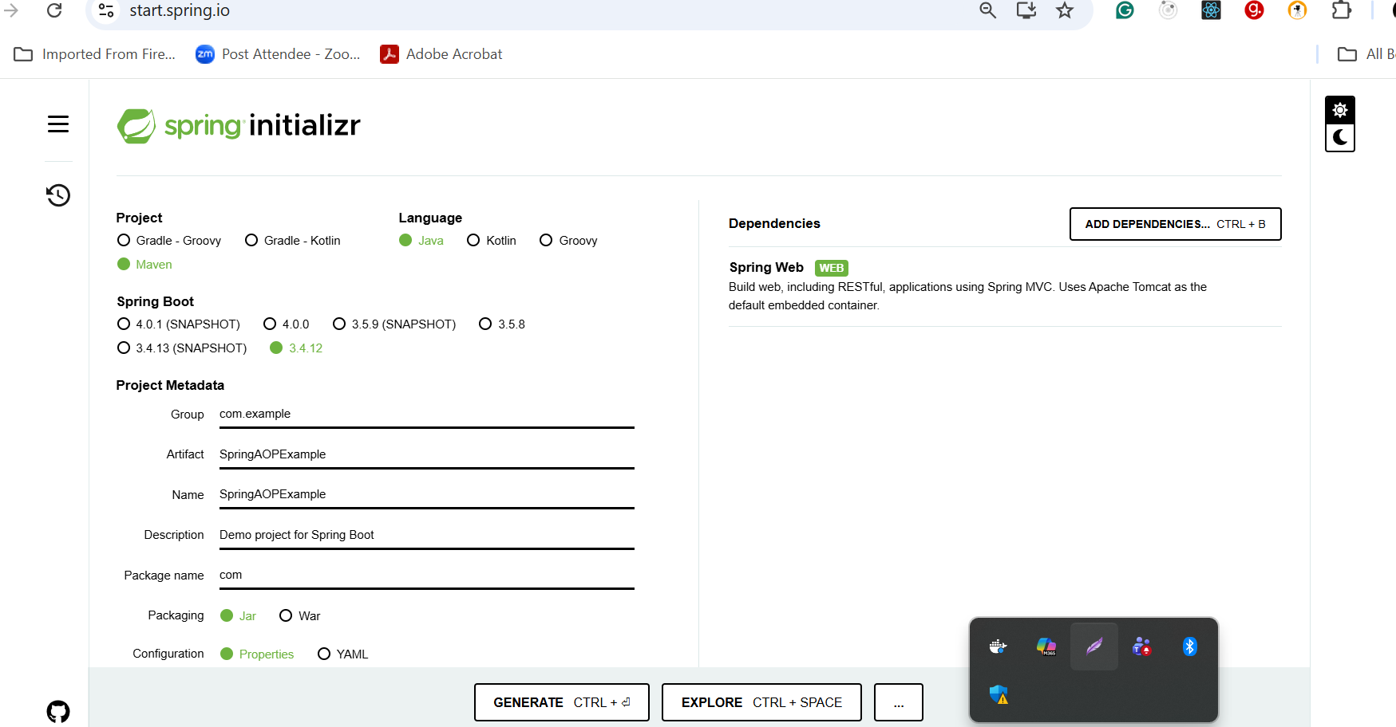

Please add manually AOP starter in pom.xml file

<dependency>
<groupId>org.springframework.boot</groupId>
<artifactId>spring-boot-starter-aop</artifactId>
</dependency>

Eureka Server

Producer Micro Service Consumer micro service

Some time producer micro service can do down with different reason. Consumer micro service can’t consume.
Circuit breaking is a fault – tolerance design pattern use to stop service from repeatedly calling a falling or down service. Using the Circuit breaker protected failure service call. If we configure circuit breaker concept in consumer micro service rather than generating error if producer micro service down we can give meaning full result as service down or sample or fake service data for temporary purpose till service become up.

Circuit breaker state
State
Closed calls go normally to external or dependent service. Failure are counted.
Open to mainly failure circuit open no mora call made. Immediately return the fallback.
Half – open after a timeout , allow limited call to rest if service can be recovered.
Closed - it rest call success normal state restored.

Old version to achieve circuit breaker in spring boot we were using Hystrix dependencies or starter.
From Spring boot 2.x to 3.x we are using resilience 4J starter.

- Eureka Server

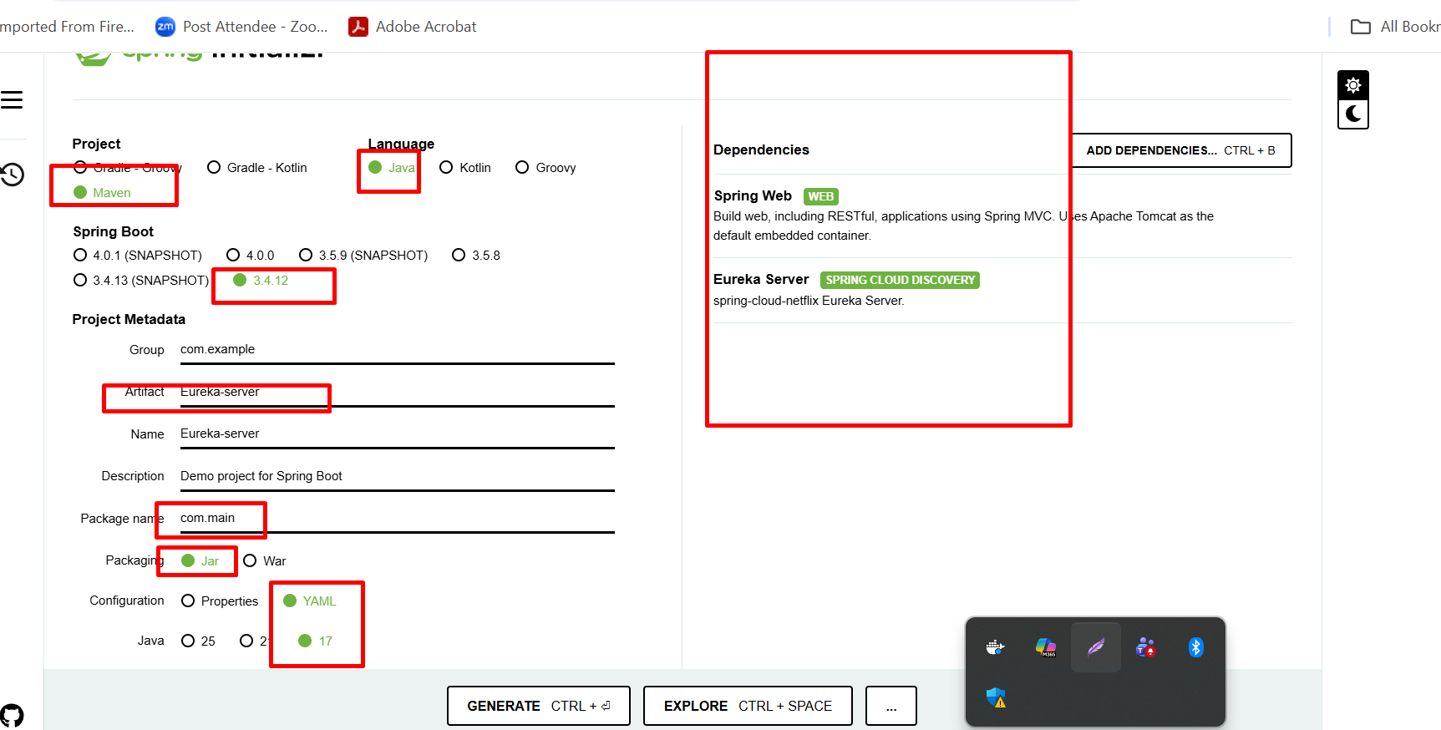

Producer micro service : 8181 port number
Web starter
Eureka Discovery client

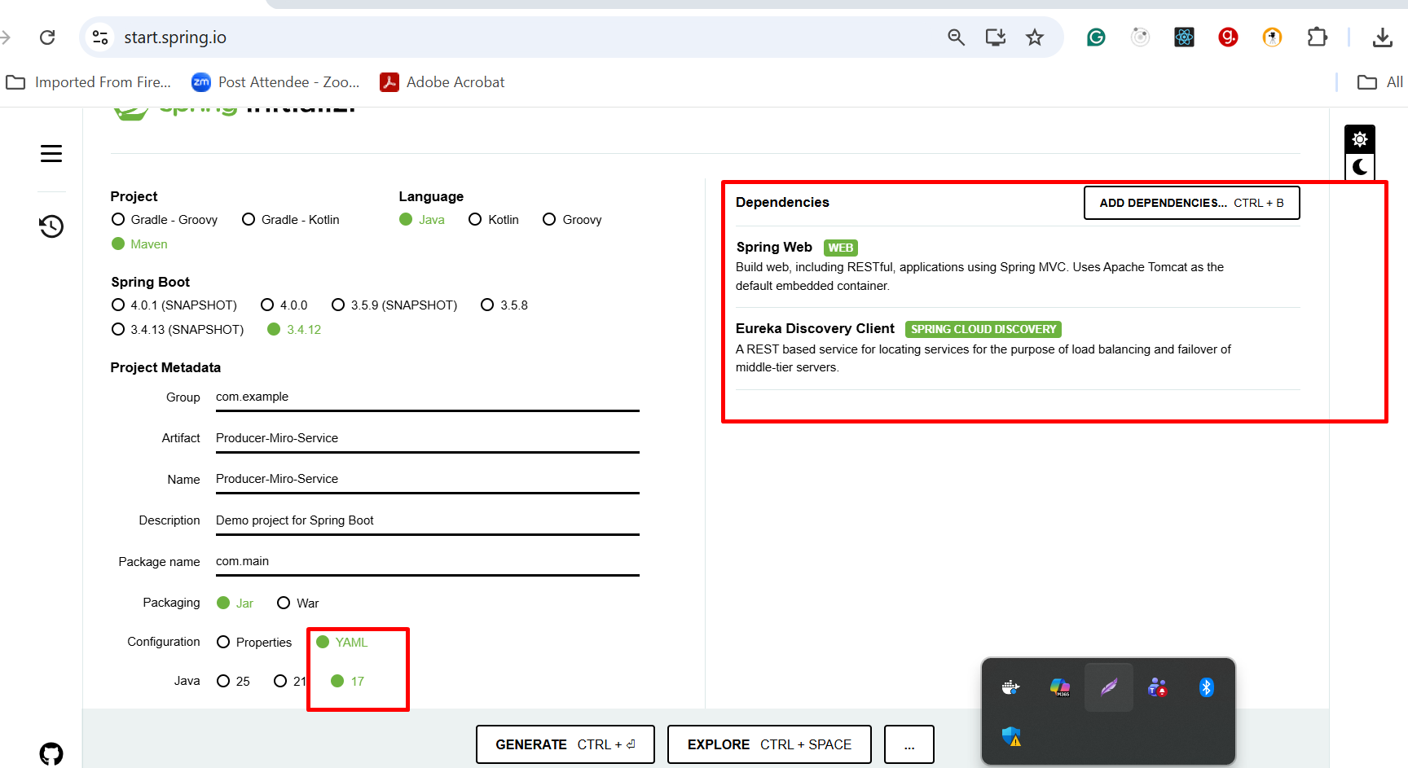

Consumer micro service : 8282 which call producer micro service using RestTemplate

Starter Starter
Starter Eureka discovery client
Starter Reslinece4j
Starter -->AOP

Manually add aop in pom.xml file

